**Oefeningen PL/SQL Hoofdstuk 2: Functies**

**Opgave 1:**

CREATE OR REPLACE FUNCTION dagen_einde_maand

RETURN number

AS

V_dagen := last_day(sysdate) – sysdate;

RETURN n_dagen;

END;

-------------------------------------------------------------------------------------------------------------

**Opgave 2:**

CREATE OR REPLACE FUNCTION aantal_dienstjaren

(p_date date)

RETURN number

AS

V_aantal_dagen number(3);

BEGIN

RETURN TRUNC(months_between(sysdate, p_date) / 12);

END;

SELECT aantal_dienstjaren(hire_date), last_name from employees;

-----------------------------------------------------------------------------------------------------------------

**Opgave 3a:**

CREATE OR REPLACE FUNCTION netto

(p_salaris employees.salary%type)

RETURN varcahr2

AS

BEGIN

RETURN to_char(p_salaris * 0.6, ‘999,999,999,00’ || ‘ euro’;

END;

SELECT netto(salary) FROM employees;

------------------------------------------------------------------------------------------------

Opgave 3b:

CREATE OR REPLACE FUNCTION netto2

(p_bruto employees.salary%type)

RETURN VARCHAR2

AS

v_netto employees.salary%type;

BEGIN

IF p_bruto <= 10000 THEN

v_netto := p_bruto * 0.6;

ELSIF p_bruto <= 16000 THEN

v_netto := 6000 + (p_bruto - 10000) * 0.5;

ELSE

v_netto := 6000 + 3000 + (p_bruto - 16000) * 0.4;

END IF;

RETURN to_char(v_netto, '999,999,999,00') || ' euro';

END;

-------------------------------------

create or replace ....

(p_jaar number)

return varchar2

as

begin

if mod(p_jaar, 400) = 0 OR (mod(p_jaar, 4) = 0 AND mod(p_jaar, 100) != 0) THEN

return p_jaar || ' is een schrikkeljaar';

else

return p_jaar || ' is geen';

end if;

end;

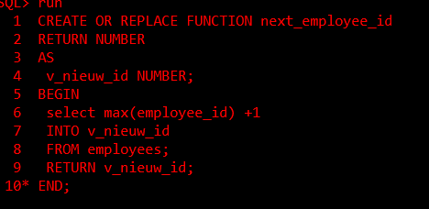

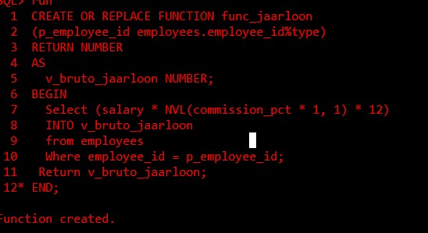

CREATE OR REPLACE FUNCTION manager_meeste_werknemers RETURN varchar2 AS v_voornaam varchar2(40); v_naam varchar2(40); BEGIN select d.department_id, count(e.employee_id) into v_depid, v_countemp from departments d join employees e group by d.department_id having count(e.employee_id) = (select max(count(department_id)) from employees group by department_id); select return v_voornaam ' ' v_naam; END; /

H 2

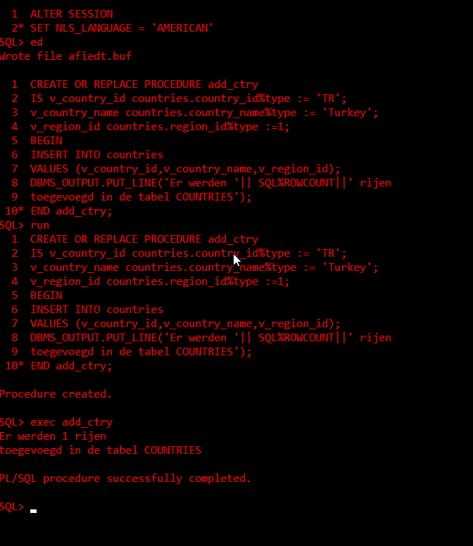

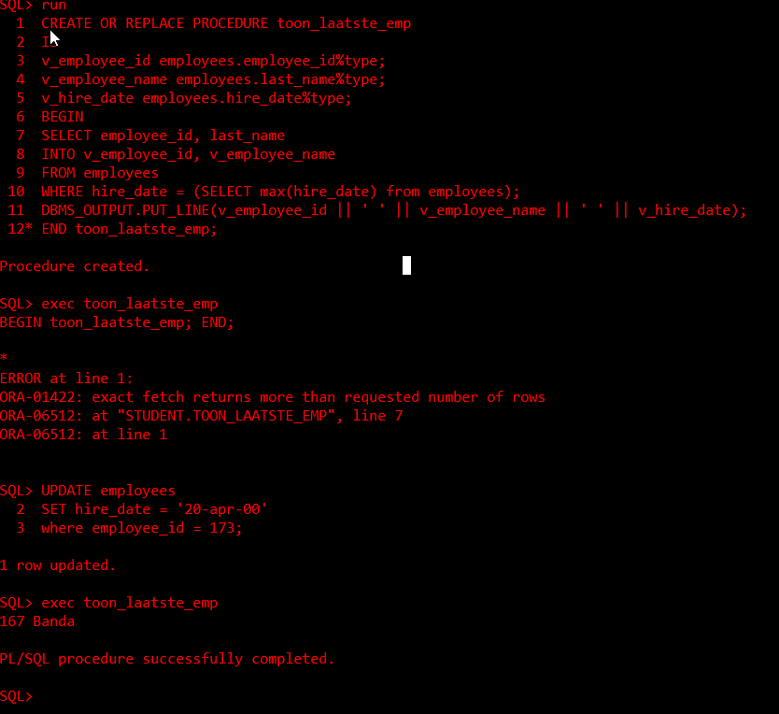

-----------------------------------------------------------------

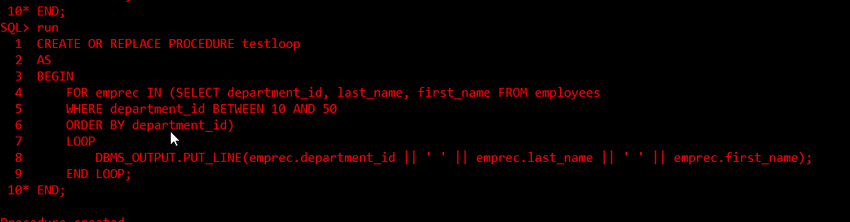

CREATE OR REPLACE PROCEDURE minimumlonen (p_landnaam IN countries.country_name%TYPE , p_nieuw_minimumloon IN employees.salary%TYPE) AS BEGIN UPDATE employees SET salary = p_nieuw_minimumloon WHERE department_id IN (SELECT e.department_id FROM employees e join departments d on e.department_id = d.department_id join locations l on d.location_id = l.location_id join countries c on l.country_id = c.country_id WHERE country_name = p_landnaam) AND salary < p_nieuw_minimumloon; END;

